**ISOM 3260**

**Group 10**

**Progress Demonstration Report**

*CHAN, Yik Fai*

*FONG, Kei Him*

*JIAN, Thomas*

*LI, Wai Yu*

*TSANG, Hiu Huen*

*WU, Minyue*

1. **Conceptual data model**

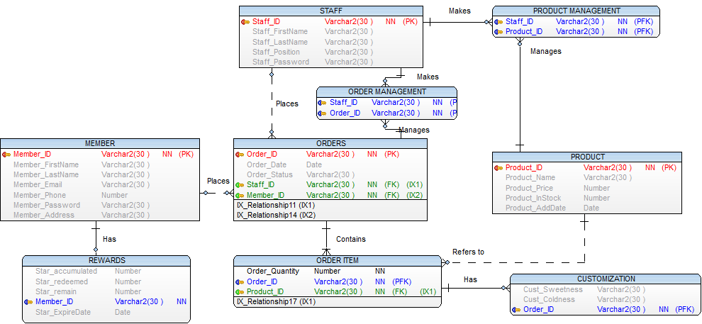

TasteJava is a newly stablished coffee company, here is the E-R diagram for its database.

MEMBER is an entity storing information of its members. It includes Member_ID, Member_FirstName, Member_LastName, Member_Email, Member_Phone, Member_Password, Member_Address. When a customer places an order by himself, he needs to login using his unique member identity, or order without login and get a random ID with empty info in other attributes.

STAFF keeps information of Staff_ID, Staff_FirstName, Staff_LastName, Staff_Position, Staff_Password.

ORDERS is an entity storing information of Order_ID, Order_Date, Order_Status. The status of an order can be updated and managed by multiple staff. One staff may manage many orders. One member may place multiple orders and an order may be placed by one member or a staff.

An order contains at least one order item. ORDER_ITEM is a weak entity of ORDERS, it has an attribute of Order_Quantity which means the quantity of the specific product/order item. The order item refers to one corresponding product in the entity PRODUCT. A product may appear in many order item lists. ORDER_ITEM has a weak entity CUSTOMIZATION with Cust_Sweetness, Cust_Coldness. Order item may have many customizations.

PRODUCT contains Product_ID, Product_Name, Product_Price, Product_InStock, Product_AddDate. A staff may manage many products and a product may be managed by many staff.

Member can get rewards when he places an order and he can make redemption later. REWARDS is an entity to store information of registered member’s rewards. It has Star_accumulated, Star_redeemed, Star_remain, Star_ExpireDate. It is the weak entity of MEMBER. A member may have 0 or 1 rewards information.

1. **Data dictionary**

|  |  |  |  |  |  |  |
| --- | --- | --- | --- | --- | --- | --- |
| **Entity: MEMBER** | | | | | | |
| Attributes | Datatype | PK | FK | Length | Not Null | Description |
| Member_ID | Varchar2 | ✓ |  | 30 | *TRUE* | Uniquely identifies Member |
| Member_FirstName | Varchar2 |  |  | 30 | *FALSE* | First name of member |
| Member_LastName | Varchar2 |  |  | 30 | *FALSE* | Last name of member |
| Member_Email | Varchar2 |  |  | 30 | *FALSE* | Email of member |
| Member_Phone | Number |  |  |  | *FALSE* | Phone of member |
| Member_Password | Varchar2 |  |  | 30 | *FALSE* | Password of member |
| Member_Address | Varchar2 |  |  | 30 | *FALSE* | Address of member |

|  |  |  |  |  |  |  |
| --- | --- | --- | --- | --- | --- | --- |
| **Entity: ORDERS** | | | | | | |
| Attributes | Datatype | PK | FK | Length | Not Null | Description |
| Order_ID | Varchar2 | ✓ |  | 30 | *TRUE* | Uniquely identifies order |
| Order_Date | Date |  |  |  | *FALSE* | Date when placing the order |
| Order_Status | Varchar2 |  |  | 30 | *FALSE* | Status of order (in progress, finished, cancelled) |
| Staff_ID | Varchar2 |  | ✓ | 30 | *TRUE* | Uniquely identifies staff |
| Member_ID | Varchar2 |  | ✓ | 30 | *TRUE* | Uniquely identifies member |

|  |  |  |  |  |  |  |
| --- | --- | --- | --- | --- | --- | --- |
| **Entity: STAFF** | | | | | | |
| Attributes | Datatype | PK | FK | Length | Not Null | Description |
| Staff_ID | Varchar2 | ✓ |  | 30 | *TRUE* | Uniquely identifies staff |
| Staff_FirstName | Varchar2 |  |  | 30 | *FALSE* | First name of staff |
| Staff_LastName | Varchar2 |  |  | 30 | *FALSE* | Last name of staff |
| Staff_Position | Varchar2 |  |  | 30 | *FALSE* | Position title of staff (cashier, manager, coffee maker) |
| Staff_Password | Varchar2 |  |  | 30 | *FALSE* | Password of staff |

|  |  |  |  |  |  |  |
| --- | --- | --- | --- | --- | --- | --- |
| **Entity: PRODUCT** | | | | | | |
| Attributes | Datatype | PK | FK | Length | Not Null | Description |
| Product_ID | Varchar2 | ✓ |  | 30 | *TRUE* | Uniquely identifies product |
| Product_Name | Varchar2 |  |  | 30 | *FALSE* | Name of product |
| Product_Price | Number |  |  |  | *FALSE* | Price of product |
| Product_InStock | Number |  |  |  | *FALSE* | Inventory of product |
| Product_AddDate | Date |  |  |  | *FALSE* | The date when the product is added to stock |
| Staff_ID | Varchar2 |  | ✓ | 30 | *TRUE* | Uniquely identifies staff |

|  |  |  |  |  |  |  |
| --- | --- | --- | --- | --- | --- | --- |
| **Entity: ORDER ITEM** | | | | | | |
| Attributes | Datatype | PK | FK | Length | Not Null | Description |
| Order_Quantity | Number |  |  |  | *TRUE* | Quantity of the product ordered |
| Order_ID | Varchar2 |  | ✓ | 30 | *TRUE* | Uniquely identifies order |
| Product_ID | Varchar2 |  | ✓ | 30 | *TRUE* | Uniquely identifies product |

|  |  |  |  |  |  |  |
| --- | --- | --- | --- | --- | --- | --- |
| **Entity: CUSTOMIZATION** | | | | | | |
| Attributes | Datatype | PK | FK | Length | Not Null | Description |
| Cust_Sweetness | Varchar2 |  |  | 30 | *FALSE* | Sweetness of ordered product |
| Cust_Coldness | Varchar2 |  |  | 30 | *FALSE* | Coldness of ordered product |
| Order_ID | Varchar2 |  | ✓ | 30 | *TRUE* | Uniquely identifies order |

|  |  |  |  |  |  |  |
| --- | --- | --- | --- | --- | --- | --- |
| **Entity: REWARDS** | | | | | | |
| Attributes | Datatype | PK | FK | Length | Not Null | Description |
| Star_accumulated | Number |  |  |  | *FALSE* | Total number of stars a member got |
| Star_redeemed | Number |  |  |  | *FALSE* | Stars that the member has redeemed |
| Star_remain | Number |  |  |  | *FALSE* | The balance of stars in the member’s account |
| Member_ID | Varchar2 |  | ✓ | 30 | *TRUE* | Uniquely identifies member |
| Star_ExpireDate | Date |  |  |  | *FALSE* | Date when stars expire |

1. **Functional Requirements**

Staff (Cashier):

1.Allow staff to insert new product information.

2.Allow staff to update product information.

3.Allow staff to update order status for orders.

4.Allow staff to place order for customer.

5. Allow staff to conduct registration for members.

6. Allow staff to retrieve/reset the login password in case they have forgotten.